Call: Next long-term volunteer at the IFM-SEI Secretariat 2022-23
IFM-SEI is looking for two enthusiastic and active members to volunteer with European Solidarity Corps in Brussels for 12 months from 1 September 2022 until 31 August 2023.
The European Solidarity Corps is a European Union initiative that creates opportunities for young people to volunteer in projects abroad that benefit communities and people around Europe.
What would I do?
As a long-term volunteer, you will be based in our Secretariat in Brussels and will work together with many volunteers all around the world and have the opportunity to see the world. The focus of a volunteering year is for you to have the chance to develop new competencies, get new experiences that will contribute to your educational and professional development, and increase your intercultural awareness. You will be able to shape your voluntary work around your interests and areas you would like to develop more.
You will also be involved in a variety of IFM-SEI projects during the year, as well as getting hands-on experience of contributing to the running of IFM-SEI. Some of the projects you may be involved with are:
- Peace Communicators: project that focuses on peace education. It aims to raise awareness of the importance of non-violent conflict resolution through getting familiar with conflict mediation and conflict prevention concepts with a particular focus on non-violent communication and critical peace education in the context of group work.
- Journey of Youth Leadership: a two-year project to strengthen youth leadership in 12 youth organization in four world regions. The aim of the project is two-folded: to share governance practices and develop ideas on how to improve transparency and internal democracy inside organisations, and to develop a leadership academy to train and coach young people (aged 18-25) in leadership skills, which will support them to take on leadership positions of groups and in boards of organisations.
- E-mpACT: three-year project aiming to address the needs of young people impacted by COVID-19 pandemic, and specifically related to digitalisation, non-formal education and international solidarity. Specifically working with 8 different countries around 4 world regions we focus on building the capacities of young people and youth workers to be able to facilitate e-learning and blended activities, do advocacy work and develop policies.
- Kids Got Rights: a project that will see young people from across Europe working together to analyse how children’s rights are met, recognised and respected in each country and then creating together a toolkit of activities, sessions plans, resources and extra information on how we can make positive change.
- Supporting thematic networks: supporting the work of one of our four thematic networks – rainbow, feminist, accessibility or migration network – to help deliver their education, campaigns and advocacy work.
What financial support do I get?
The position is voluntary, however there is financial support for the volunteer (if the grant is accepted) by the means of:
- accommodation in Brussels (in a shared flat/house);
- an allowance that includes money for meals, local transport and pocket money;
- travel costs to Brussels (a lump sum depending on the distance to Brussels);
- insurance for the whole year;
- a language course (French or Dutch);
- European Solidarity Corps training programme and lots of training and development opportunities within IFM-SEI and our member organisations;
- an exciting and unforgettable experience, working for an international organisation in an international city.

Can I apply?
You can apply if you fit the following profile:
- Aged between 18 and 30 (must have reached 18 and must not be older than 30 at the start date of the activity);
- Active in a member organisation of IFM-SEI in Europe and Middle East;
- Able to work in English (Spanish and/or French would be an advantage);
- Able to commit to a year of volunteering in Brussels;
- Computer literacy skills;
- Basic knowledge of non-formal education;
- Support from your IFM-SEI member organisation;
- Your organisation holds Quality Label for volunteering projects;
- The motivation to take back what you have learnt to your IFM-SEI member organisation and share good practice;
- Open-minded, friendly and flexible.
We particularly encourage young people with fewer opportunities to apply. We welcome applications from individuals irrespective of gender, disability, marital or parental status, ethnic or social origin, colour, religion, belief, or sexual orientation.
How do I apply?
If you are interested then send your CV, a motivation letter (up to one-page A4) and a support letter from your organisation. The motivation letter should outline why you would like to join IFM-SEI for a year as a long-term volunteer and what you feel you could bring to the role. We would ask for you to send all application documents to contact@ifm-sei.org by Monday, 16 May 2022 (23:59 CEST).
Please spread the word! If you have any questions, please don’t hesitate to get in touch with Pia on pia@ifm-sei.org or contact@ifm-sei.org.
Still not convinced? Hear about first-hand experience from previous volunteers...
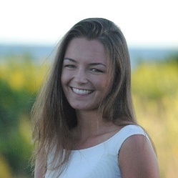  Julia, ESC 2021-2022  ESC is a great opportunity to move to somewhere new and work with a lot of different people. I love working with the IFM-SEI member organisations, being a part of the projects and getting to meet a lot of old and new friends!  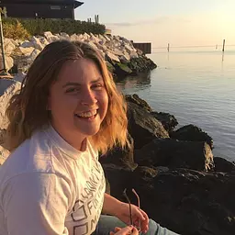  Aggie, ESC 2021-2022 | During my time as an ESC volunteer, I got to move to Brussels to work in the IFM-SEI secretariat. Here, I was able to work with member organizations across the world and travel to different projects. This is an experience to work as well as develop your skills in the areas that you are interested in.
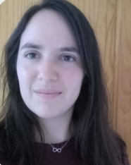  Iris, ESC 2020-2021 | This year has been a year of uncertainty, change and inexperience, but above all it has been an adventure and a learning experience. This experience gives you the opportunity to get to know new forms of internationalism and cooperation, to learn new skills and to apply what you already know. This year has been an unforgettable year for everyone, but for me it has meant getting out of my comfort zone and getting to know myself, my limits and what I am capable of doing.
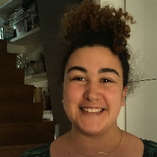  Nadia, ESC 2019 | My European Solidarity Corps volunteer placement with IFM-SEI has been so incredible because I have had a unique opportunity to learn skills, meet people and develop my international perspective and outlook! The best part of this programme for me is that you drive your own learning and development, so I have really had the chance to think about what I want to develop and make that happen myself by doing! I have had the chance to learn about non-formal education, facilitation, as well as the more operational sides of project management. I would recommend this position to people who are looking for a dynamic, motivating and interesting working environment.
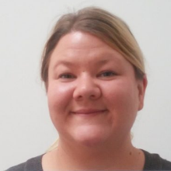  Jassu, ESC 2018 | My voluntary year in IFM-SEI was amazing. I learned a lot about the world around me and how powerful educational work can be. I had many unforgettable opportunities and memories which I wouldn't have without this experience. Now I have many new friends around the world and better knowledge to continue educational work on local level.
Frankie, EVS 2015-16 | My EVS with IFM-SEI was really special because it gave me so many incredible opportunities and I learned a lot about myself and what I value. I was based in Belgium for the year but it felt like I was actively practicing internationalism; I made lots of amazing new friends from all over the world.
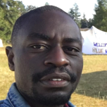  Arnold, EVS 2015 | My EVS was a life-changing experience. It is the biggest opportunity that I have ever gotten in my whole life. It was my first step into professional life. My EVS was also a life-saving experience. Working with IFM-SEI and being surrounded with great people sharing socialist values was extremely helpful. It provided me with the safe space that I needed at that moment. Doing an EVS also helped me learn a lot about myself and the world around me. It was a journey to my inner being that gave me the necessary skills and attitude that I needed in order to become an actor of positive change.
Delphine, EVS 2012 | I won't be exaggerating when I say that my EVS (European Voluntary Service) experience launched a new career path for me, introducing me to internationalism. Today, I have gained so much exposure from the opportunities that my EVS created for me, made a network of great and inspiring international friends. I have been recognized both nationally, regionally through awards and gained international scholarships all thanks to my experience during my EVS.

This call is open to young people residing in the EU Member States and the following Partner Countries: Iceland, Liechtenstein, Turkey, Republic of North Macedonia, Norway and countries from Western Balkans, Eastern partnership Countries, and South-Mediterranean Countries.
If previously accredited with ESC52, you are able to be a partner/sending organisation until the end of the programme (2027). If you haven't been previously accredited with KA110 or ESC52, you have to re-apply for the Quality Label as a partner organisation.

