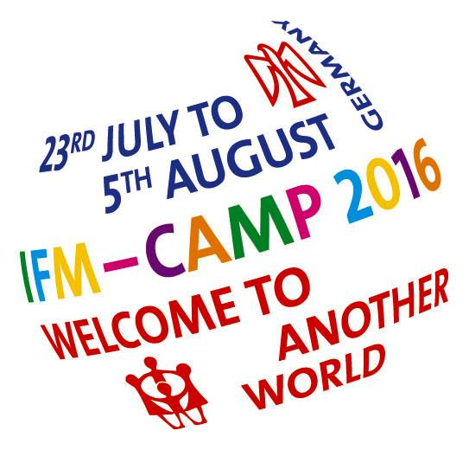
IFM-SEI Camp 2016 in Reinwarzhofen

Our demands for another world

Under the motto “Welcome to Another World”, SJD-Die Falken hosts the camp of the International Falcon Movement-Socialist Educational International (IFM-SEI) in Reinwarzhofen.

From 23rd July to 5th August, 2500 children and young people from over 30 countries meet on the Willy-Brandt Zeltlagerplatz to live and learn together, have fun, discuss political issues, form opinions and build another world.
All delegations are part of IFM-SEI, an international socialist children and youth movement fighting for social justice, equality, solidarity, children’s rights and a world free from capitalism.

At the camp, the children and young people have developed political demands during dozens of workshops on our core themes of equality and socialism, antifascism and antiracism, LGBTIQ, women and children’s rights, cooperation and peace.

These are our demands:
- We demand a world where solidarity, and friendship and blue skies are hold above profit and violence and where no one has to live in fear.
- We demand women’s right to equal pay and an end to patriarchy.
- We demand governments to take action to prevent and combat violence against women.
- Nous demandons que le racisme n’est plus accepté dans notre société.
- We demand equal human rights for LGBTIQ people.
- We demand a world that recognizes and supports the participation of children, young people and minority groups in decision-making processes in families, schools, and communities and on all levels of society.
- We demand open borders without visa restrictions, so that children and young people can fully participate in international activities, sharing and learning with one another.
- Nous demandons les enfances en paix et un environnement sain pour tout les enfants, n’importe leur origine.
- We demand that children and young people living in conflicts are not forgotten, no matter how far away the conflict seems from us.
- We demand that Sinti and Roma can live wherever they want without having to face discrimination, racism and poverty.
- We demand a stop of racist asylum policies and closed borders. All refugees are welcome and the human rights of all must be respected.
- Nous demandons un monde sans capitalism, avec l’egalité et justice sociale pour toutes et tous dans le monde.

As an educational movement, we want to build a new world through discussion and games and by living in solidarity with people around the world. Together we can fight for socialism and educate for social change.

