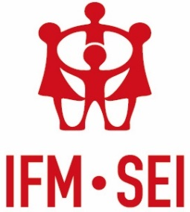
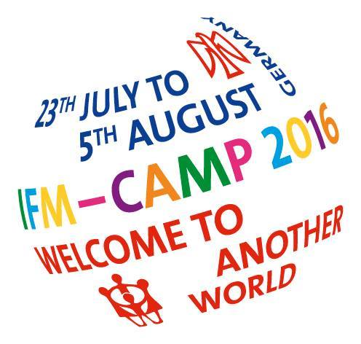
IFM Camp 2016 Welcome to another World – Contributing to the Programme

During the IFM Camp 2016 ‘Welcome to Another World’, there will be eight theme tents with programme running for the whole two weeks and everyone will have the opportunity to contribute to the programme. One of the most important and exciting parts of the IFM Camp 2016 is the educational programme, and organised workshops are one of the main parts of this.
You might have just one concrete idea of a tried and tested activity that works really well and you would like to offer to the camp programme. Or you might want to get really involved in the team for one of the theme tents. You don’t even have to have any concrete ideas at all, just some enthusiasm to make the IFM Camp 2016 brilliant. Either way, think about how you can contribute, fill in this form and return to contact@ifm-sei.org

Name:
Contact email address:
IFM member organisation:
Programme area(s) of interest: (You can find descriptions of each of the following programme areas through this link: http://ifm-sei.org/articles/welcome-to-another-world-call-for-workshops )
- Democracy and participation
- Peace
- Rainbow
- Co-operation
- Equality and socialism
- Anti-racism and anti-fascism
- Women and trans*
- Children’s rights
Ideas for workshops/ activities:
Please indicate which age group the activity would be suitable for, its duration, an outline and any materials necessary.

