A&O HOSTEL- audit report
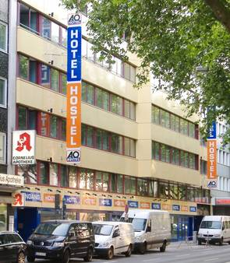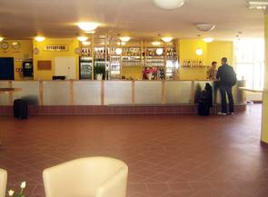
On first impressions the hostel looks disability friendly with ramps on the ground floor to the reception area but this is where the impression begins to change. The counter is too high for wheel chair use being impossible for someone in a wheel chair to see the receptionist.
On arrival there is a short step to encounter followed by a very heavy door. On the ground floor there is a disabled toilet which is also used to store cleaning equipment. There are some rooms on the ground floor which have been adapted for wheelchair use but the dining room is in the basement and all meals are served there. There is a lift but it is not suitable for wheelchair access as it is far too small and is also not suitable people with hearing or visual impairments as it doesn’t tell you what floor you are going to.
The car parking is in the sub basement (two floors down) and has no access to the lift there are stairs to the reception area via two very heavy fire doors. If one was to try to leave by the car ramp this would be too difficult as the ramp is too steep and also would mean a journey of some 120 metres and encounter the step at the main entrance.
There are no aids to hearing in the hostel or the seminar rooms there is also no visual fire alarm system in any of the public rooms. There are some visual signs but no symbols.
Joni and Tom (Woodcraft)

